LEANFT JUNIT PROJECT:

1. LEANFT Runtime engine will automatically get started when you start your IDE.If not enable your Runtime engine as shown below

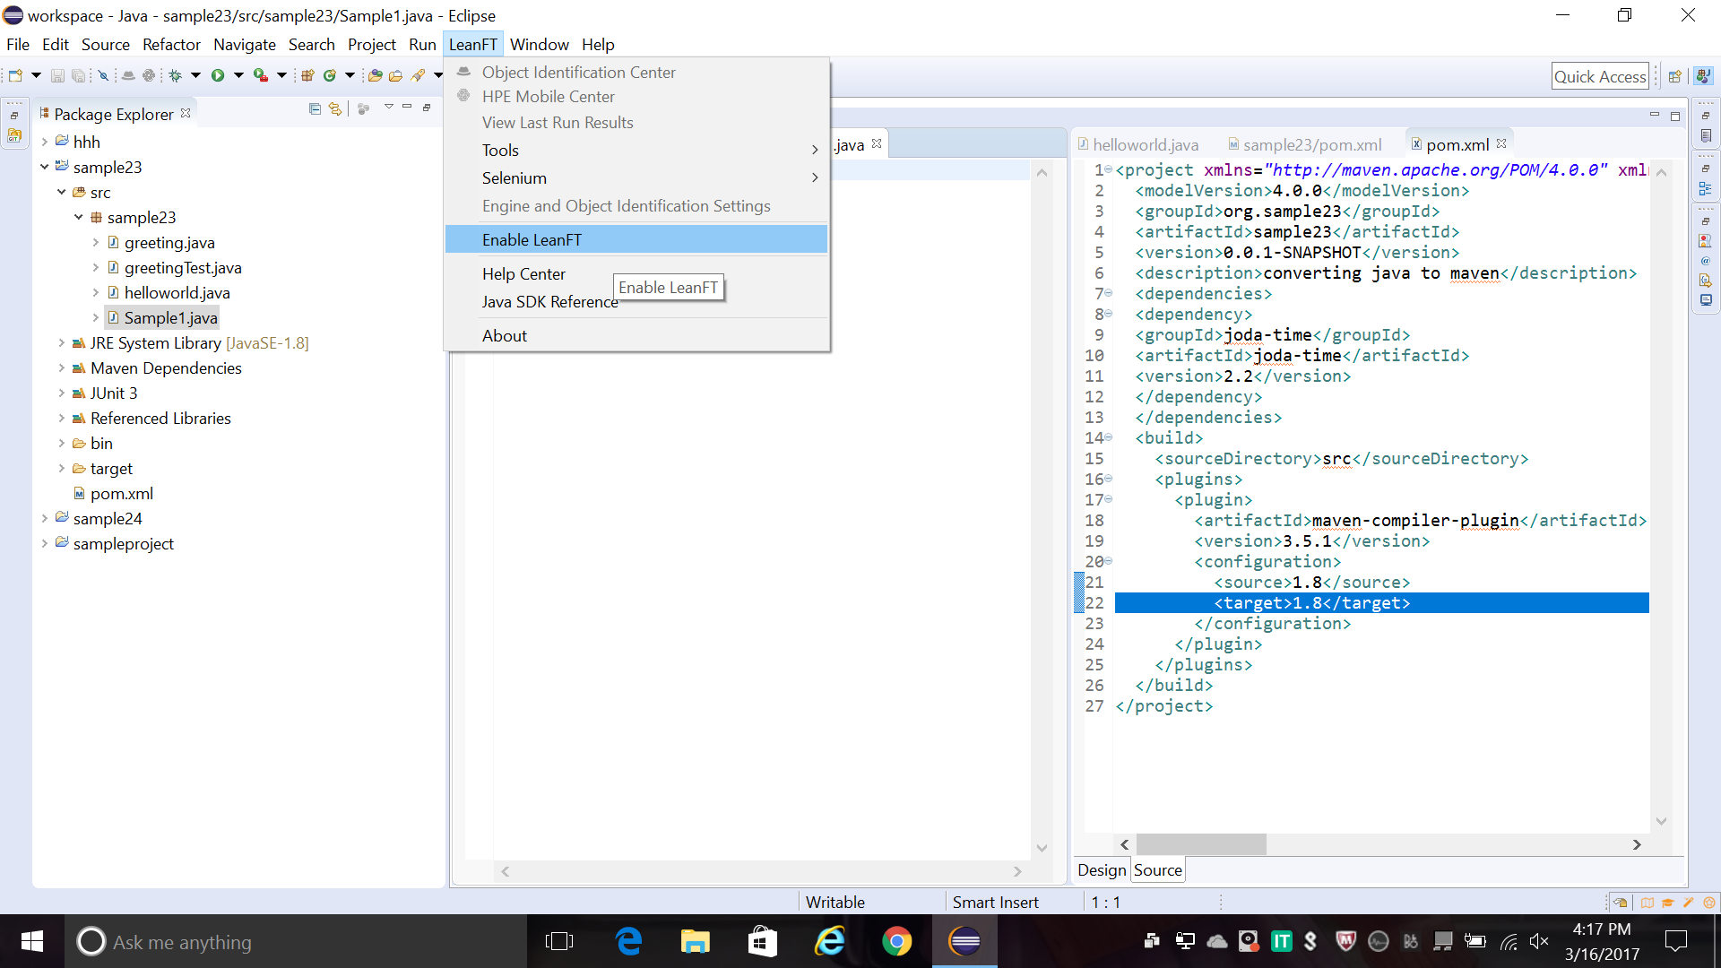

1. To create a new leanft junit test project Goto File->other options

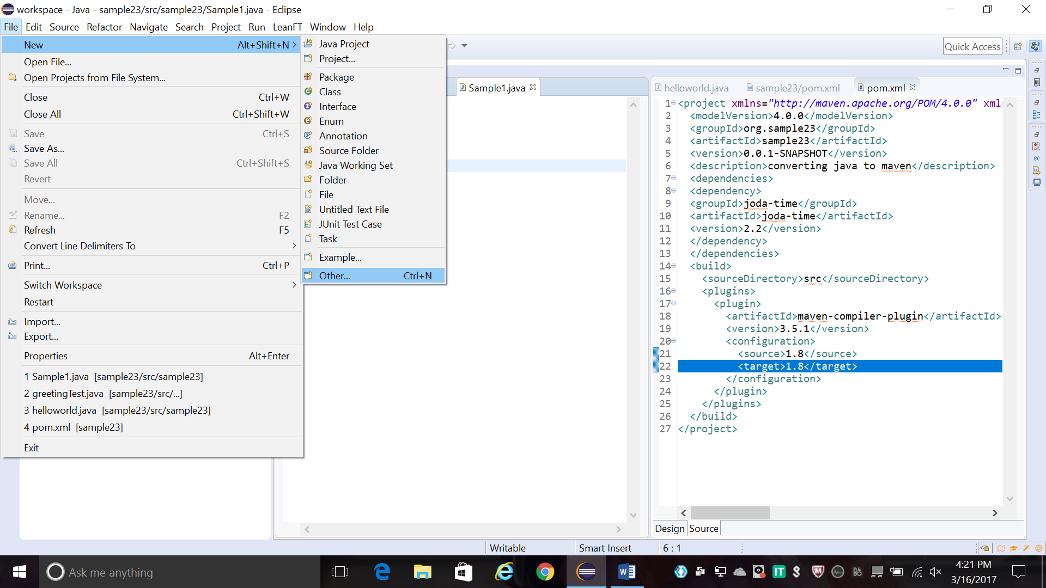

1. Leanft Provides various options. you can select LeanFt testing project to create a new Junit test project.

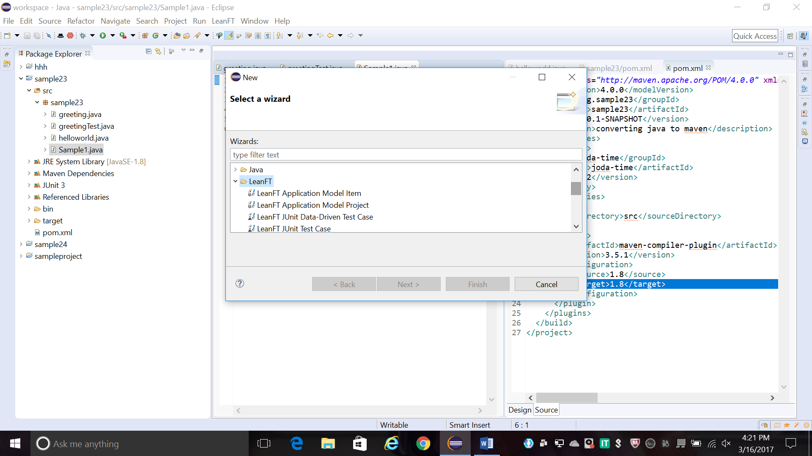

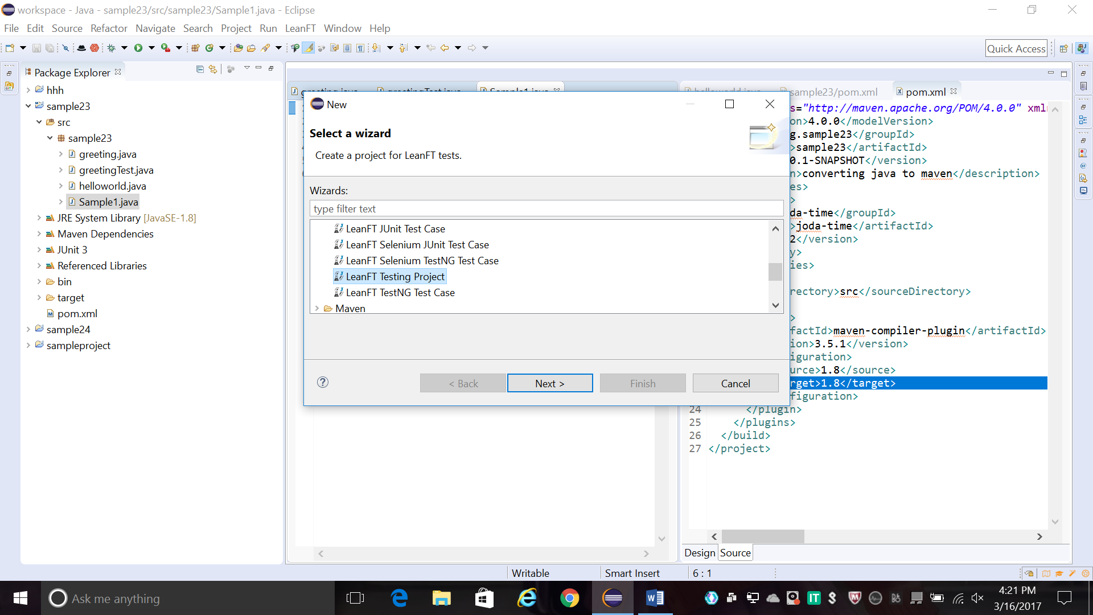

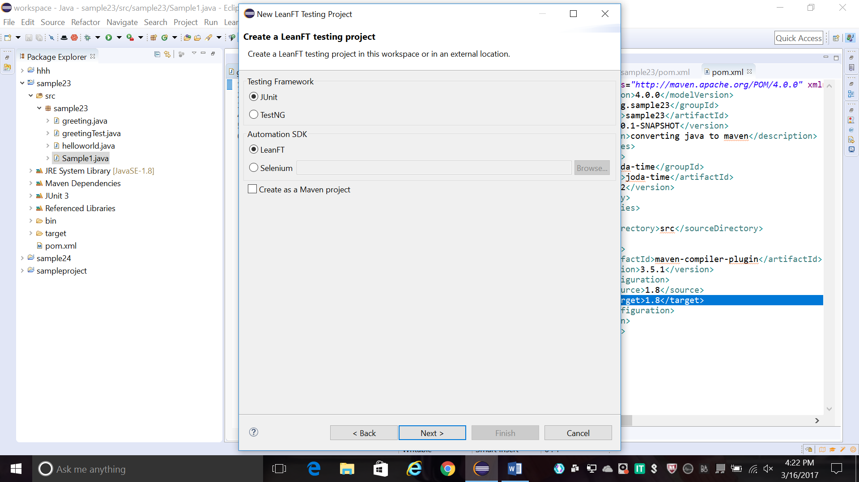

1. Once you setup .you can specify your project name and package for creating the project

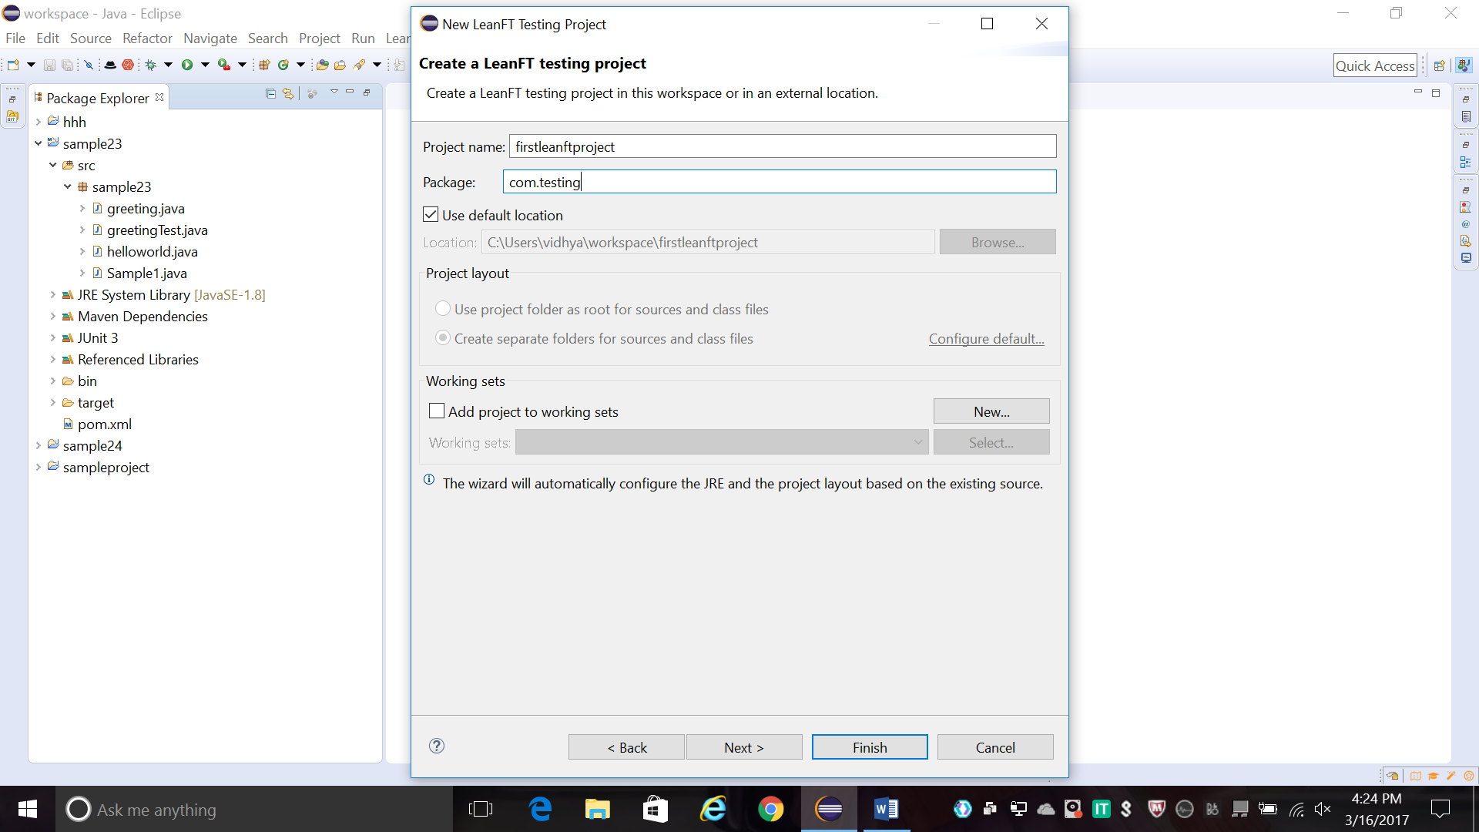

1. The new Leanft Junit testing project is created.

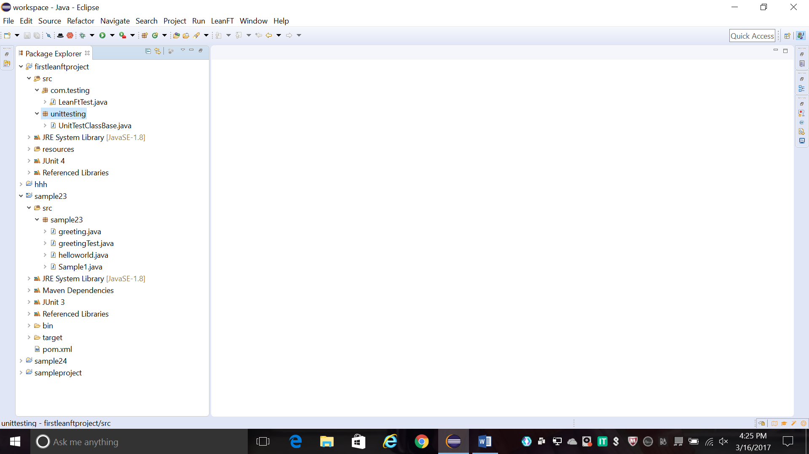

1. Here a sample advantage shopping website is tested.

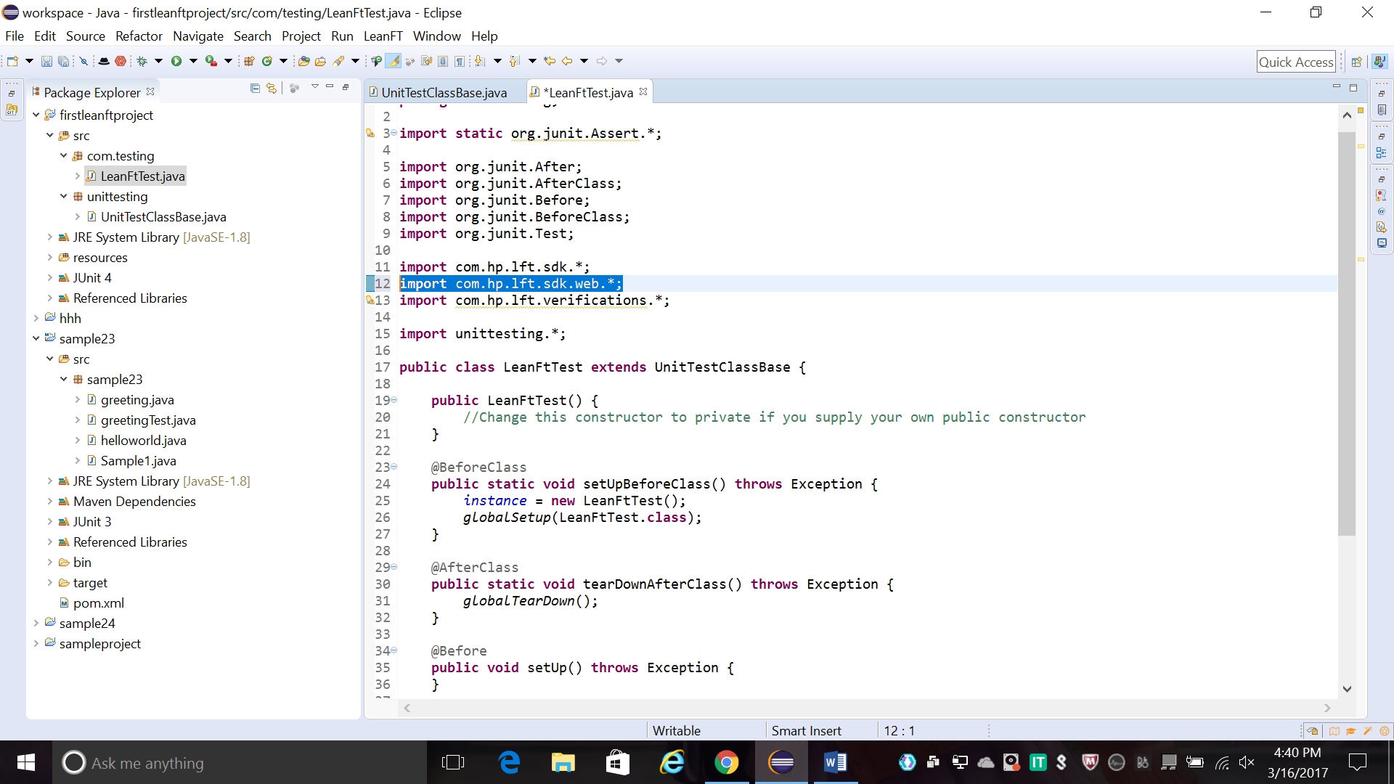

1. The browser Type can be of your choice either(chrome, IE or Firefox)

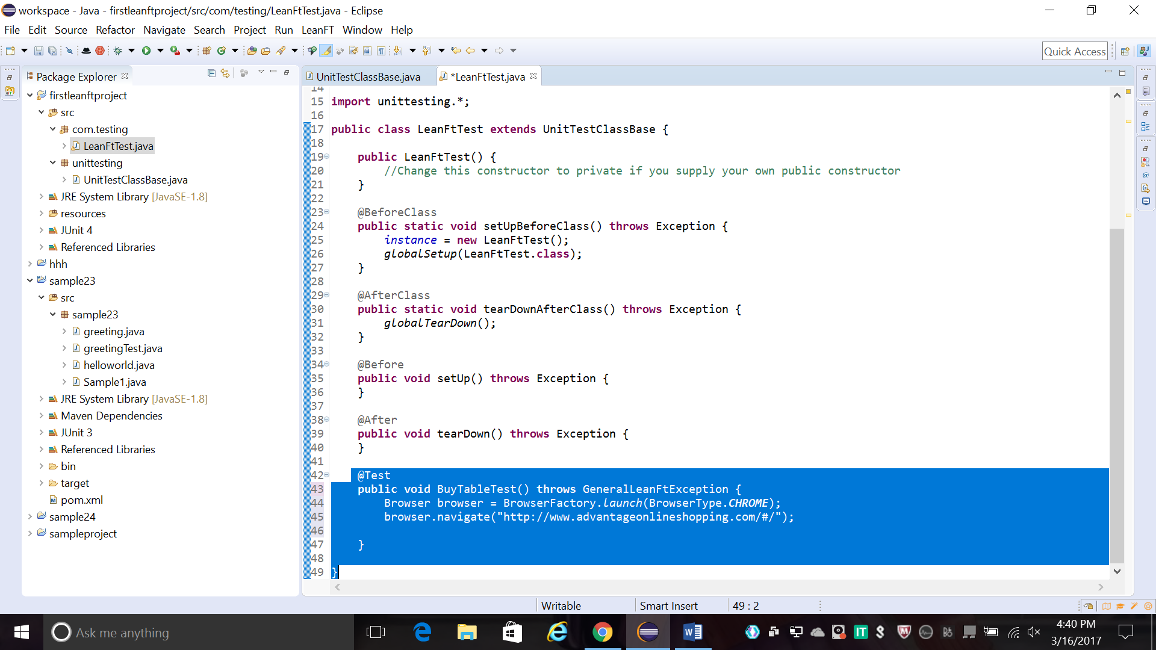

1. LeanFt provides tool called object Identification center(OIC).which helps to spy objects in your application it generate code to use in your scripts,or add objects to your application model.

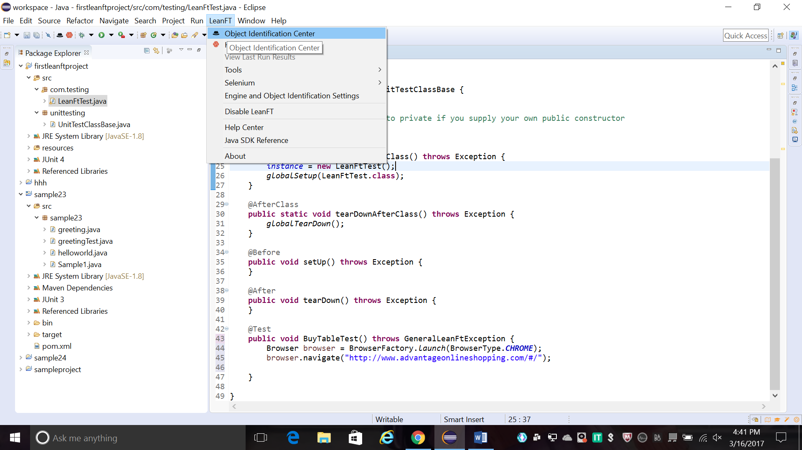

1. You can start spying your test objects using OIC. It recognize object properties.



10.once your object properties are recognized you can edit properties using edit mode.

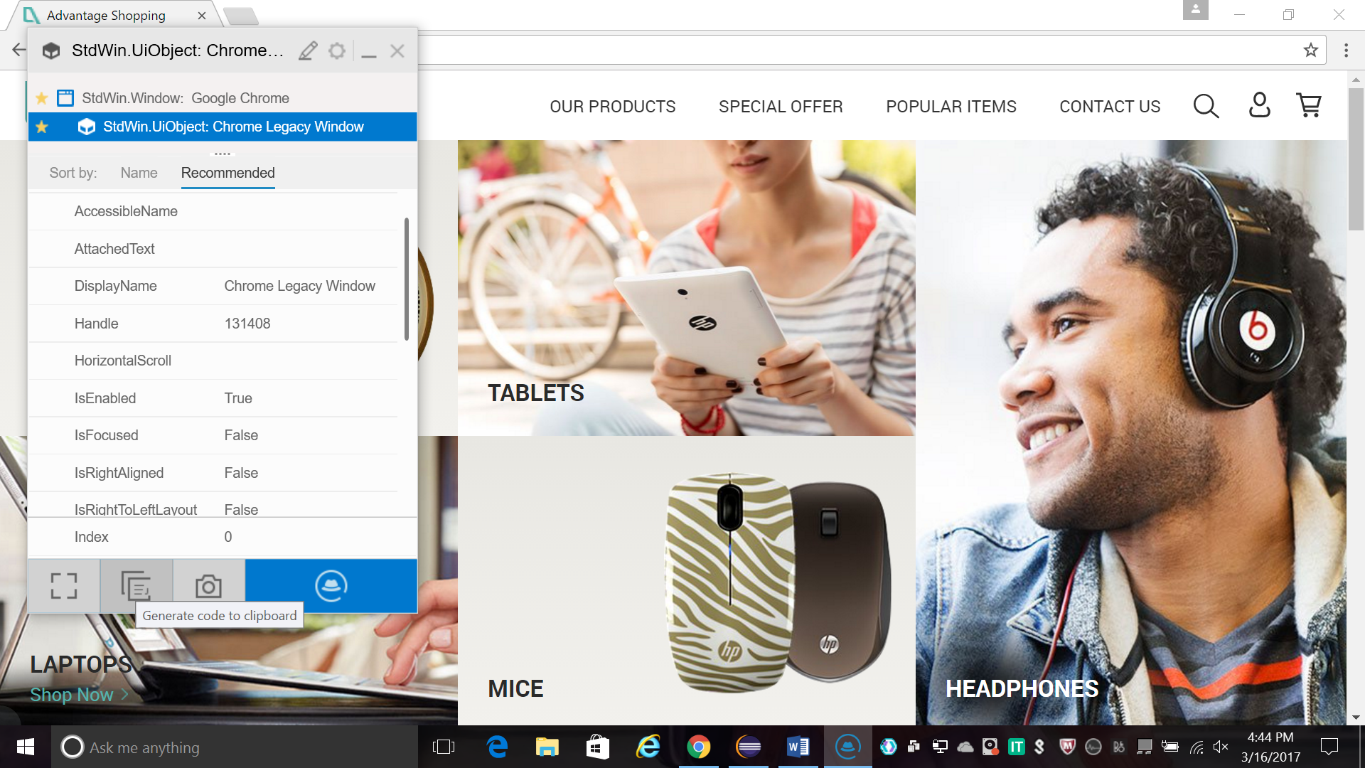

1. You can write your script using the object properties recognized by OIC

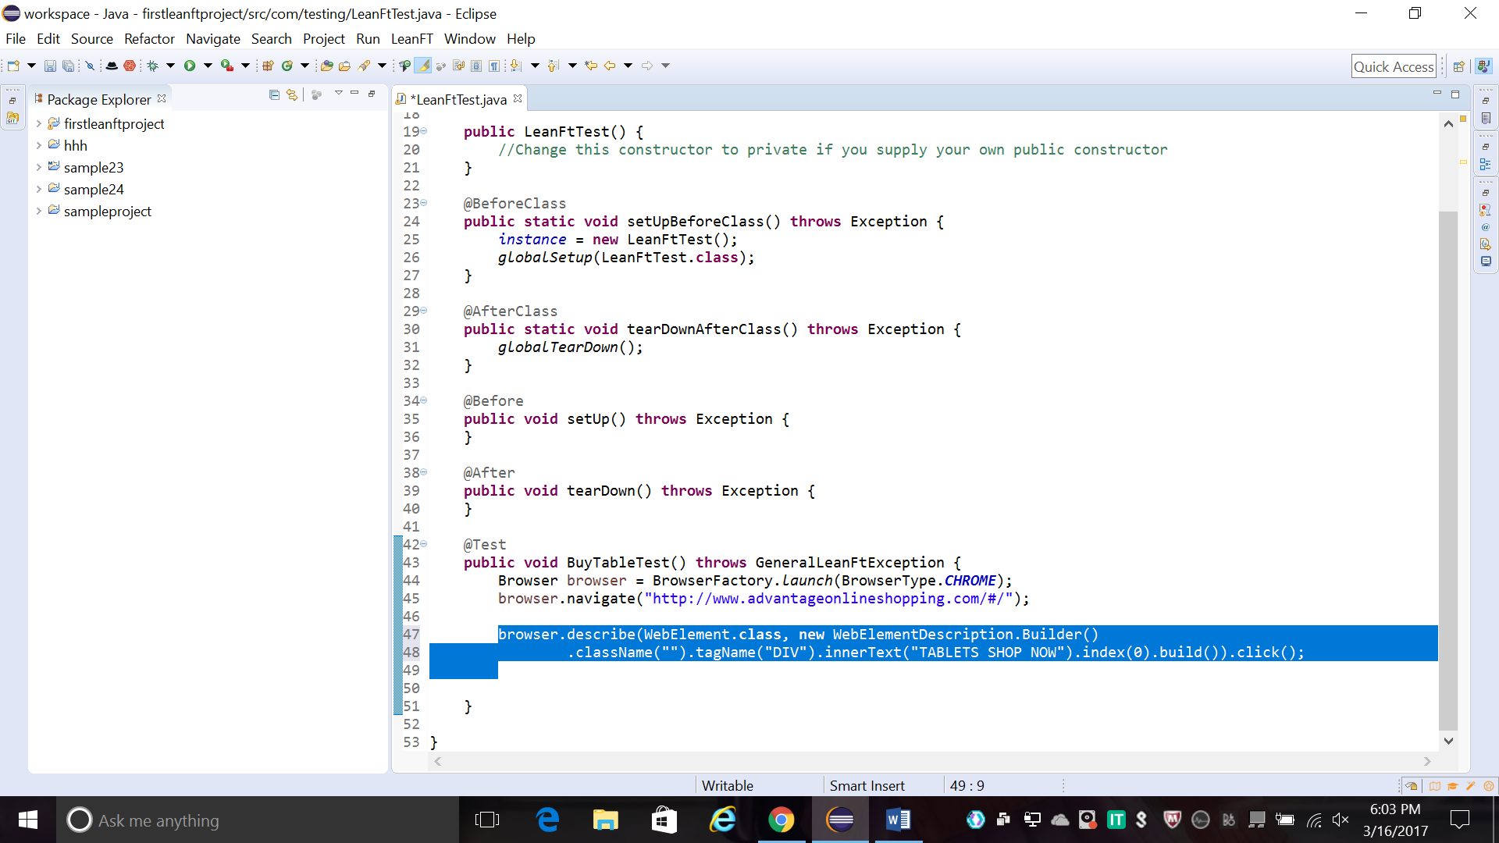

1. Run your project.

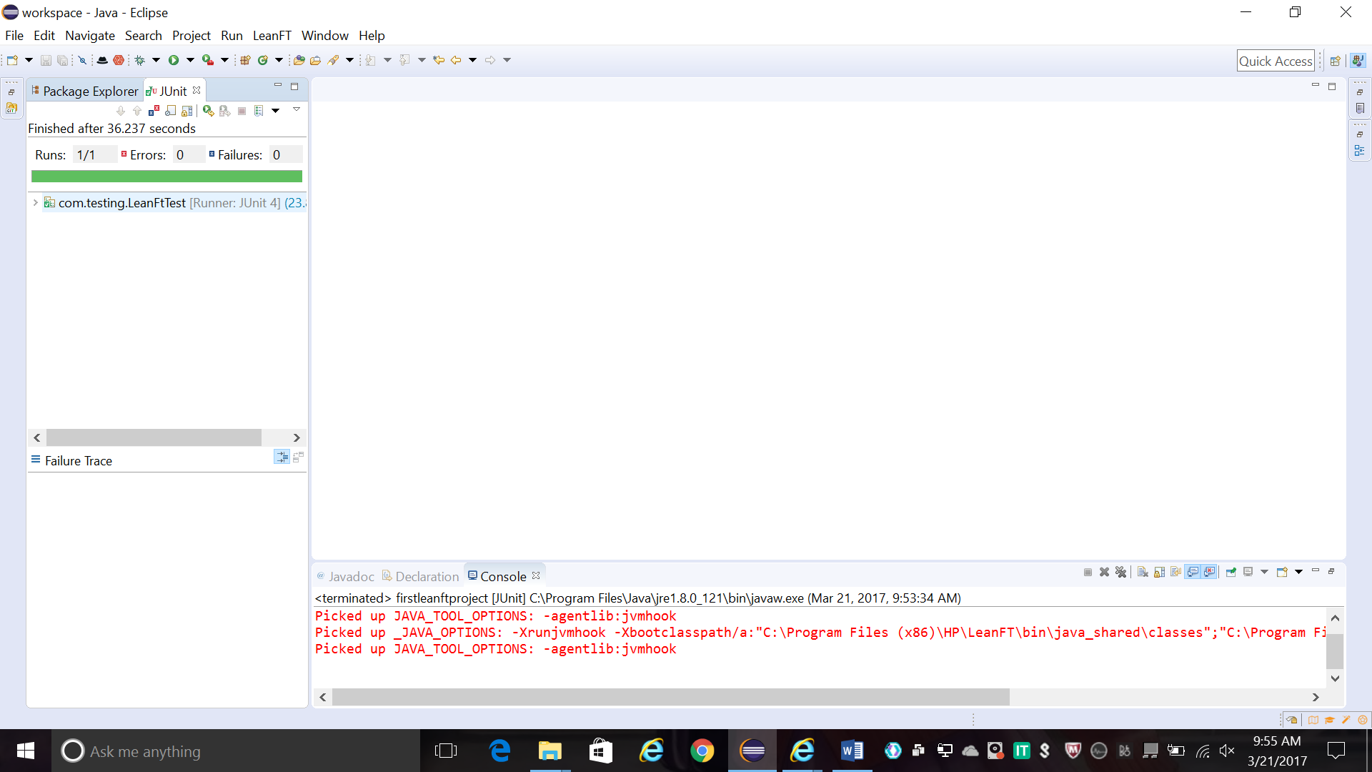

1. LeanFt Test Report is created.Goto Leanft->View Last Run Results

